**MOBILE SERVICE MANAGEMENT SYSTEM (MSMS)**

**MAHIMA ANANTH CHOWDARY POTTLURU**

**https://github.com/mahesh279/database-systems.git**

**30/04/2022**

**Week5**

In continuation from wk4 the below mentioned are the outcomes for wk5.

**Indexes**

**Define-Generate-Demonstrate:**

For my MSMS project I have chosen two tables named as ‘accessories’, ‘devices’ for indexing. The idea being choosing these two tables is that, I would like to explore more on future stock requirements of accessories for fast moving devices and devices are going to be outdated/ obsolete.

From accessories table I prioritized to have Accessory name for indexing. Below mentioned is the query about it.

**CREATE** **UNIQUE** **INDEX** Acc_name **ON** accessories (Acc_Name);

**CREATE** **UNIQUE** **INDEX** Dev_make **ON** devices (Dev_Make);

Instead of Indexing on single column you can go for more columns for it.

The advantage with **INDEX** is when we use INSERT and UPDATE statements it take more time on tables having indexes, whereas the SELECT statements become fast on those tables. The reason is that while doing insert or update, a database needs to insert or update the index values as well.

**SELECT** Acc_Name,Acc_In_Units **FROM** accessories **WHERE** Acc_Name = 'RAM';

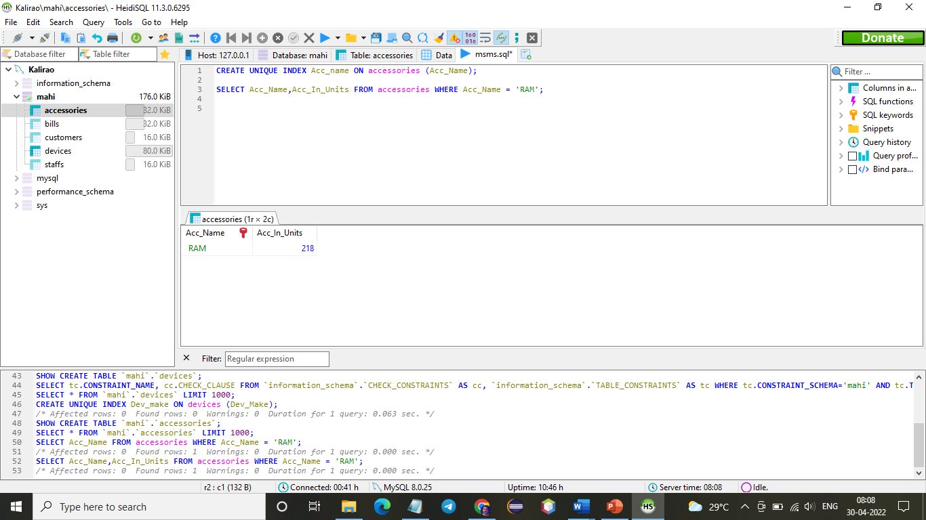

**SELECT** Dev_Accessories,Dev_Make **FROM** devices **WHERE** Dev_Accessories = 'RAM';

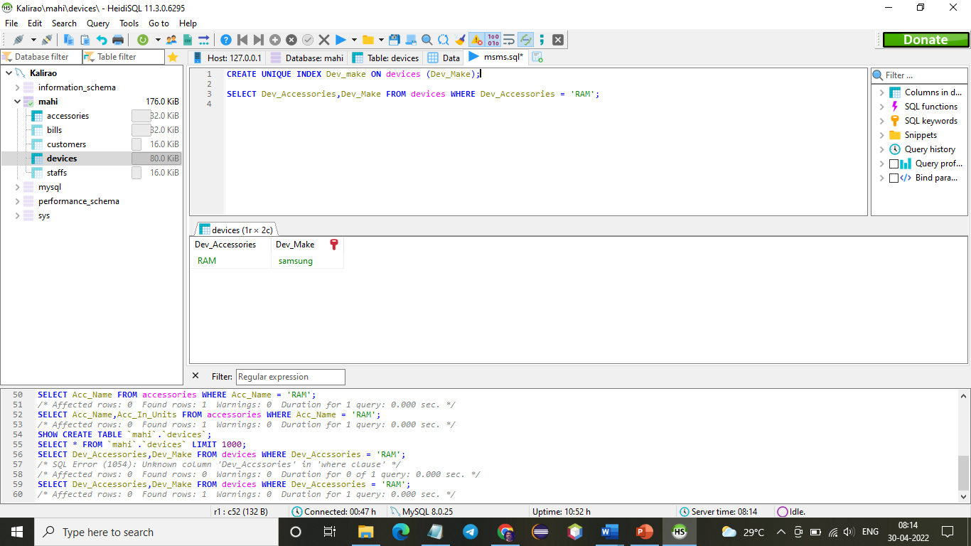

**Views:**

View is nothing but a virtual table based on the result set of SQL statements.

Creating a view can be possible with CREATE VIEW command.

CREATE VIEW syntax is

CREATE VIEW view_name AS  
SELECT column1, column2, ...  
FROM table_name  
WHERE condition;

**CREATE** **VIEW** view_dev_accessories **AS**

**SELECT** Dev_Accessories, Dev_Make

**FROM** devices

**WHERE** Dev_Make = 'oppo';

To see the created view

**SELECT** * **FROM** view_dev_accessories;

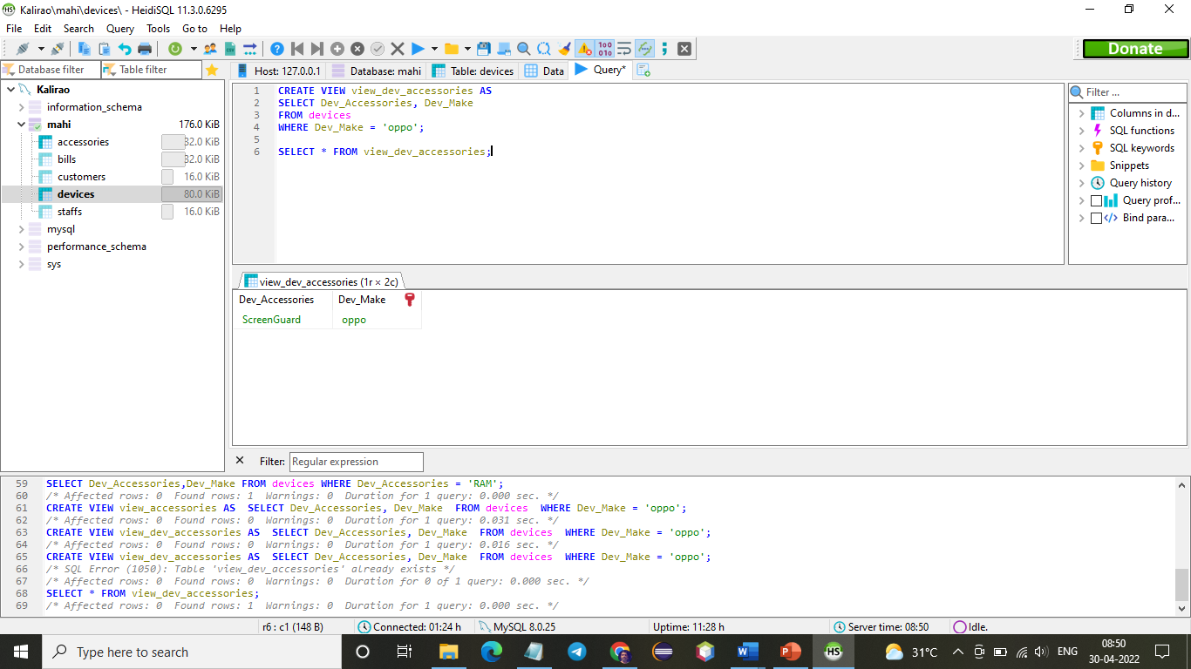

As discussed above view table is a temporary table, that can’t get saved into database and will erase as soon as session terminates. The purpose of this views table is to generate a mini-table that shows values of specific fields for better understanding the data in quick and structured way.

The ALTER VIEW statement is used to modify or update the already created VIEW without dropping it.

The SYNTAX for ALTER VIEW is

**ALTER** **VIEW** view_name **AS**

**SELECT** columns

**FROM** **table**

**WHERE** conditions;

**ALTER** **VIEW** view_dev_accessories **AS**

**SELECT** Dev_Accessories, Dev_Make, Dev_Version

**FROM** devices;

**SELECT** * **FROM** view_dev_accessories;

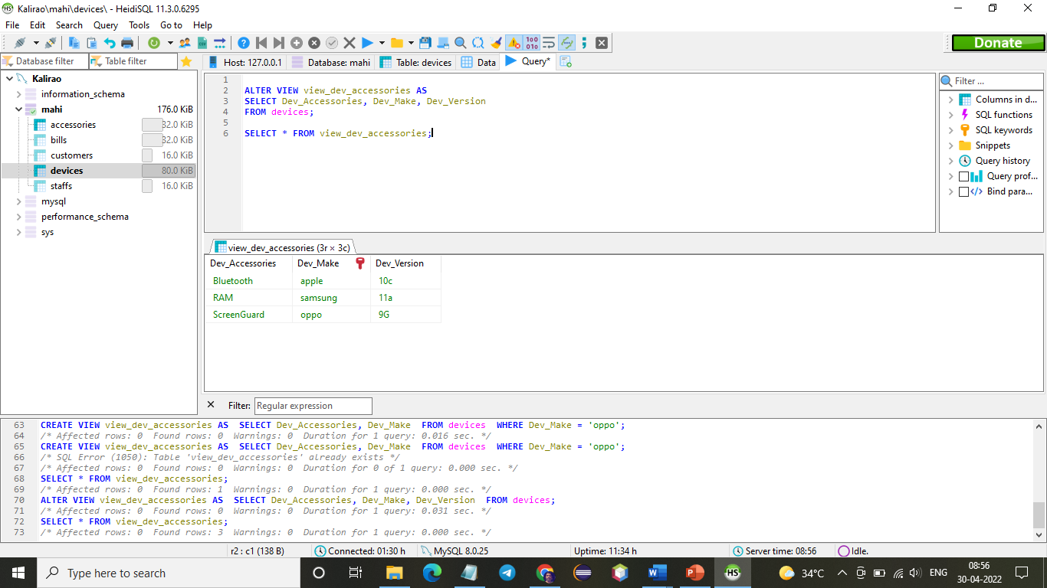

**Each VIEW a value addition to database?**

Yes, of course, even though MSMS database consists of tables with so many columns and bundles of sensitive information that we can’t give access to all the users. Instead we generate different VIEW tables meeting specific requirements.

**Who case better use this VIEW?**

An example that says authorization requirements state that the technician from staff can only see accessories details like, accessory name, available quantity but without its purchasing price. To achieve this, you can create a VIEW of this type.